**Low Level Design - Bus Management System**

Table of Contents

1. Revision History 2

2. Approval 2

3. Target Audience/Distribution List 2

4. Reference Documents 2

5. Introduction 3

6. Use Cases 3

a) Description 3

b) Process Flow Diagram 3

c) ER mapping 3

d) Class Diagram 3

7. Design 3

a) Forms 3

b) Database 3

c) Middle Tier 3

8. Data Unit Mapping 4

9. Acronyms and Abbreviations 4

# Revision History

| Revision Number | Change By | Changes Incorporated |
| --- | --- | --- |
| PA1 |  | Initial Draft |
|  |  |  |
|  |  |  |
|  |  |  |
|  |  |  |

# Approval

| Approved By | Designation | Approval Type |
| --- | --- | --- |
|  |  | Provisional/Final |
|  |  |  |
|  |  |  |
|  |  |  |
|  |  |  |

# Target Audience/Distribution List

| Name | Designation |
| --- | --- |
|  |  |
|  |  |
|  |  |
|  |  |
|  |  |

# Reference Documents

| Document Name | Location  Physical Location/Website |
| --- | --- |
| HLD-<Project Name> |  |
|  |  |
|  |  |
|  |  |
|  |  |

# 

# Introduction

The Low-Level Design element is presented here to design every element during the development of the web-based project, Bus Management System, along with a detailed understanding of the data flow and to assist the programmer throughout accomplishing development activity on time. For each Use Case that our web application will cover, we generate a Process Flow Diagram, Entity Relation Mapping, and a Class Diagram in the Low-Level Design. We prepare the design for the form elements, the detailed database design, and the layout of the java classes in addition to the Detailed Description of the Use Cases. In the Data Unit Mapping, we associate each form attribute with its corresponding Database Column.

# Use Cases

6.1 User registration/login

1. Description

In the registration page the user will find a button for registration or login which will take the user to the log in or the registration page. For admin a separate button will be provided for login in the footer which will take the admin to admin login page. Depending on whether the user is logging in or admin, the value of ‘isAdmin’ will be set in the users table.

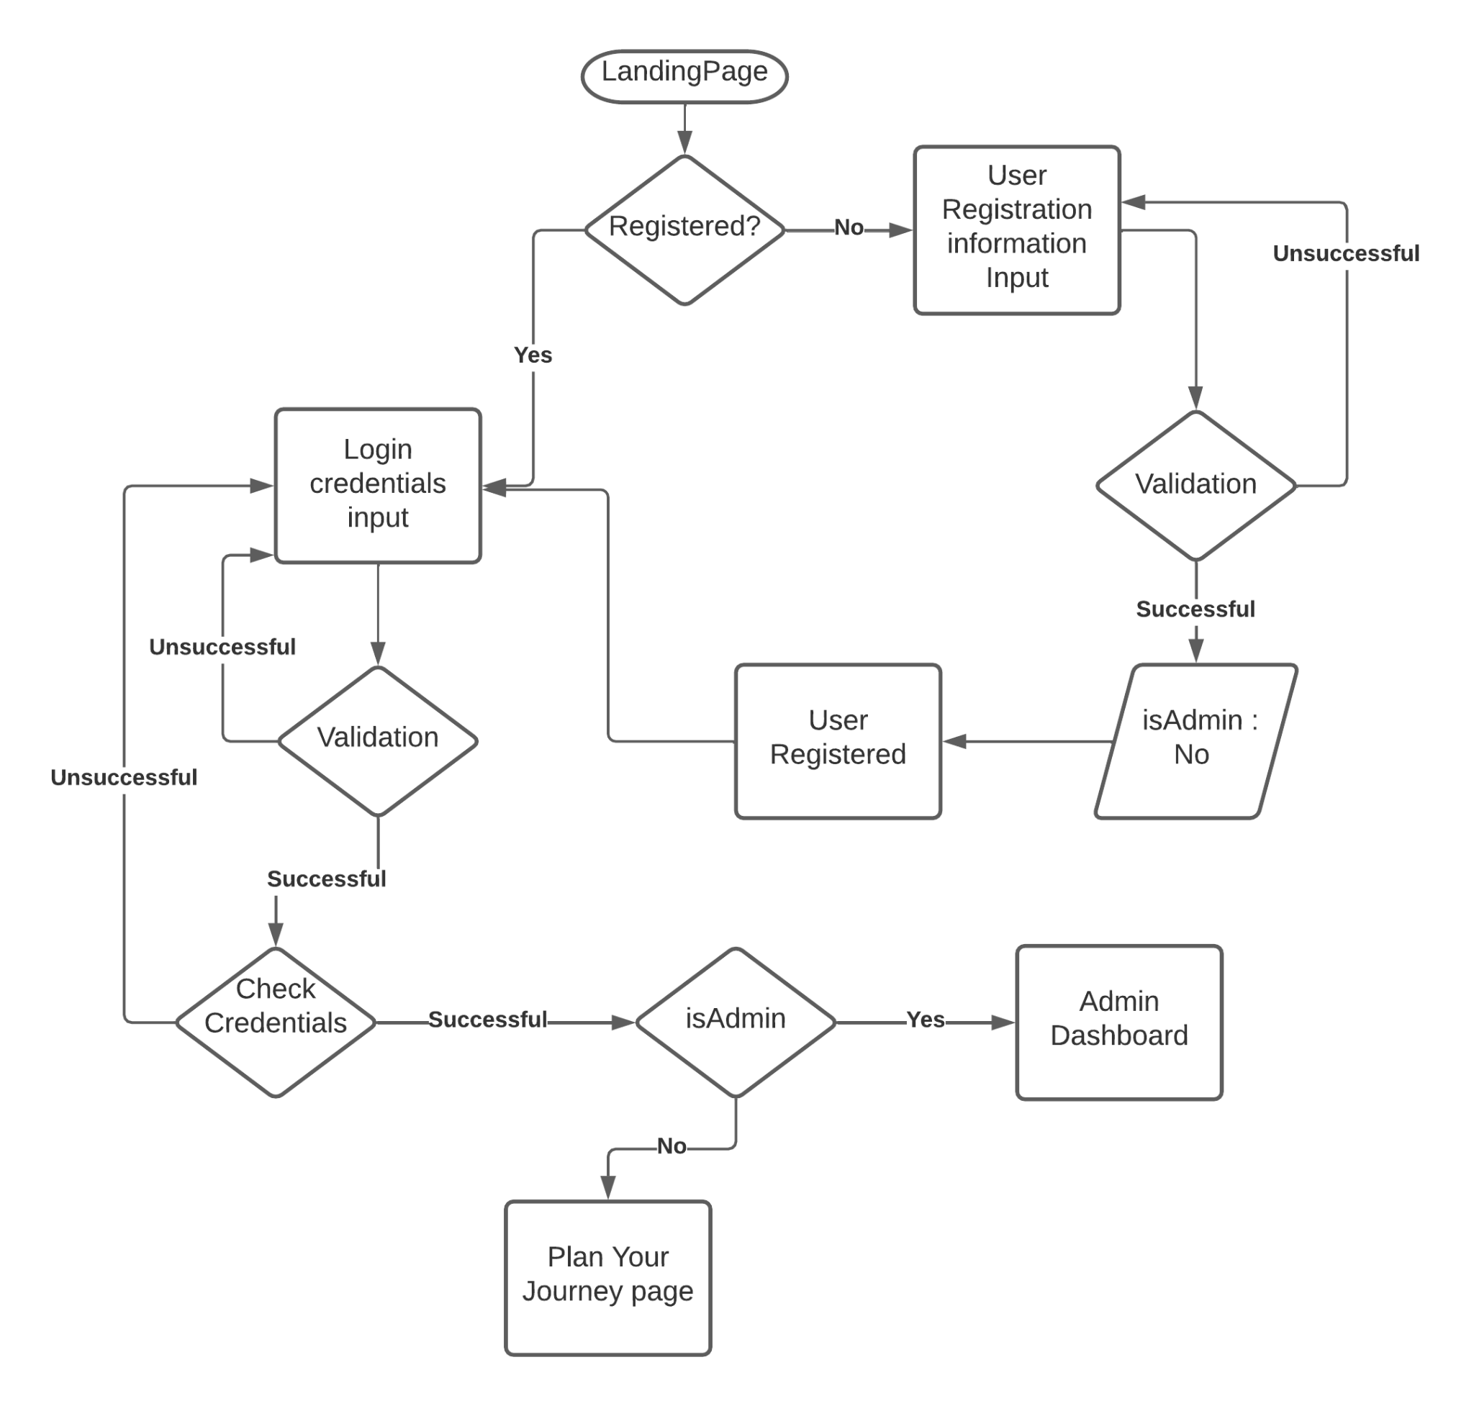

1. ER Mapping

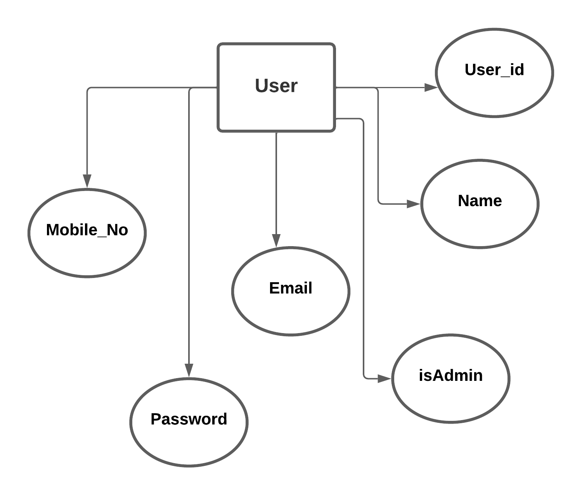

1. Class Diagram

6.2 Passengers can see all bus information between two stops.

1. Description

Users can enter a start point, a destination point and date of traveling inside a form and press the “Search Bus” button. Then the system will find the route having that starting and ending point from the route table and retrieve all the bus information from the bus table, running on that particular route. If no such route is available then it redirects to the same page.

1. Process Flow Diagram

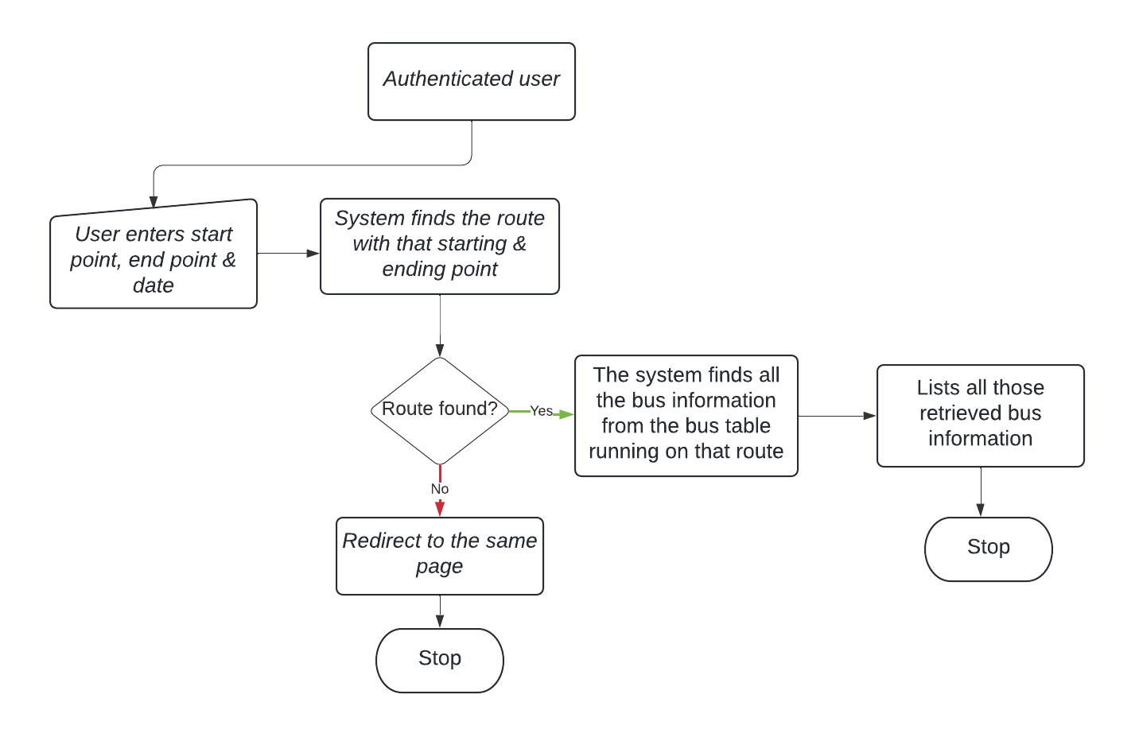

1. ER Mapping

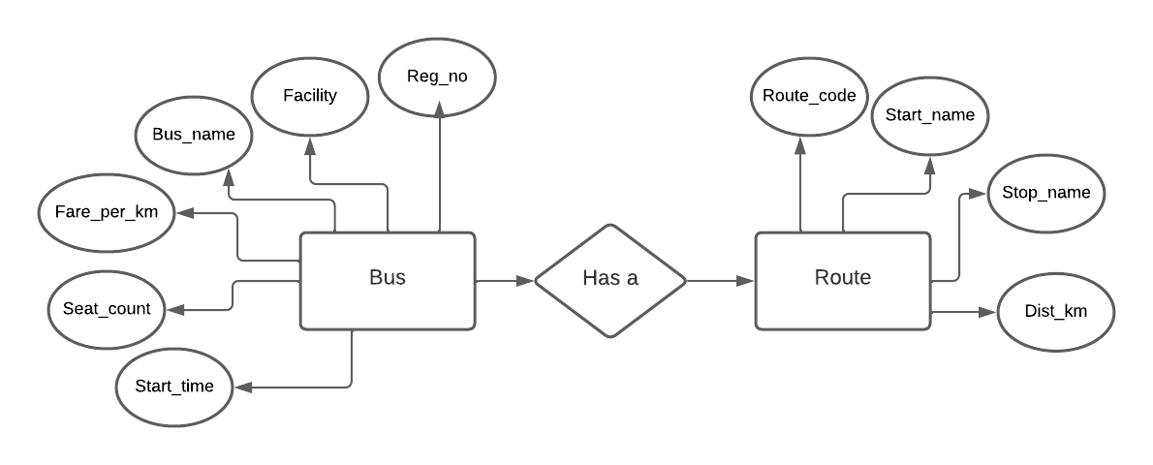

1. Class Diagram

6.3 Book a Bus Ticket

## Description

The user selects the date of travel(a month in advance can only be booked), boarding location, and destination location, after which a list of available buses is displayed, the user selects his/her most preferred bus from the list, the user must select the number of seats he/she is booking and the final fare is displayed, and the booking of the ticket is confirmed for the user by clicking on the book button.

## Process Flow Diagram

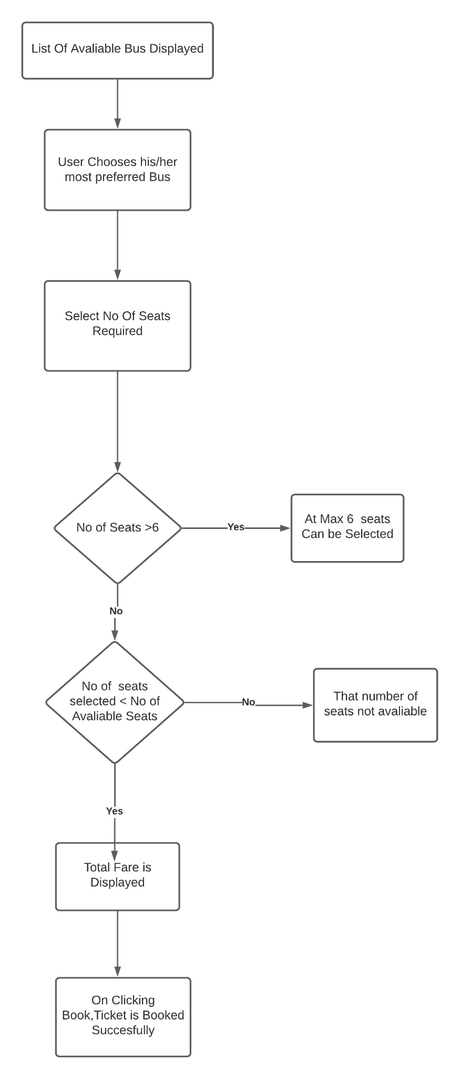

## ER mapping

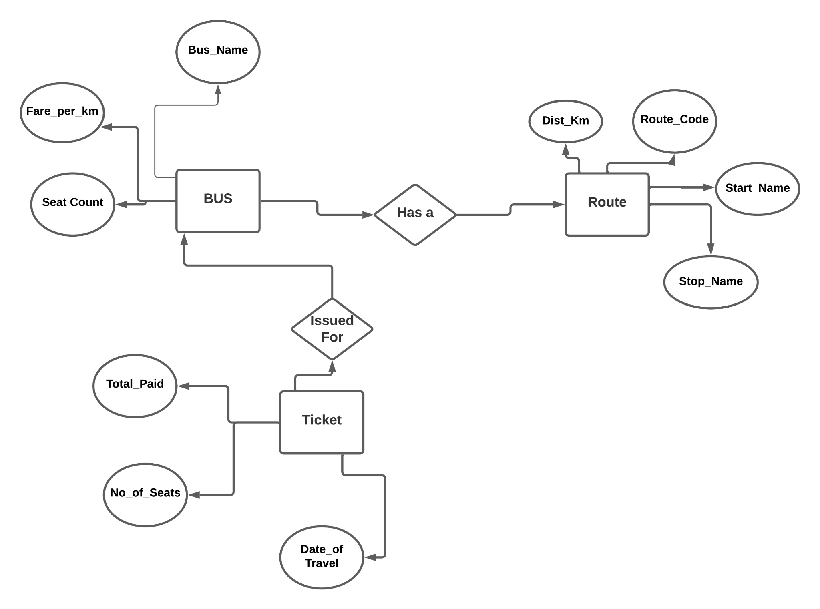

## Class Diagram

6.4 Cancel a Ticket as a whole

a) Description

If the ticket has been booked from the Bus Management System and the user wishes to cancel the ticket, then the user can cancel the ticket as a whole. And, the allocated seats will be freed from the database and will be available for further booking.

b) Process Flow Diagram

## 

c) ER Mapping

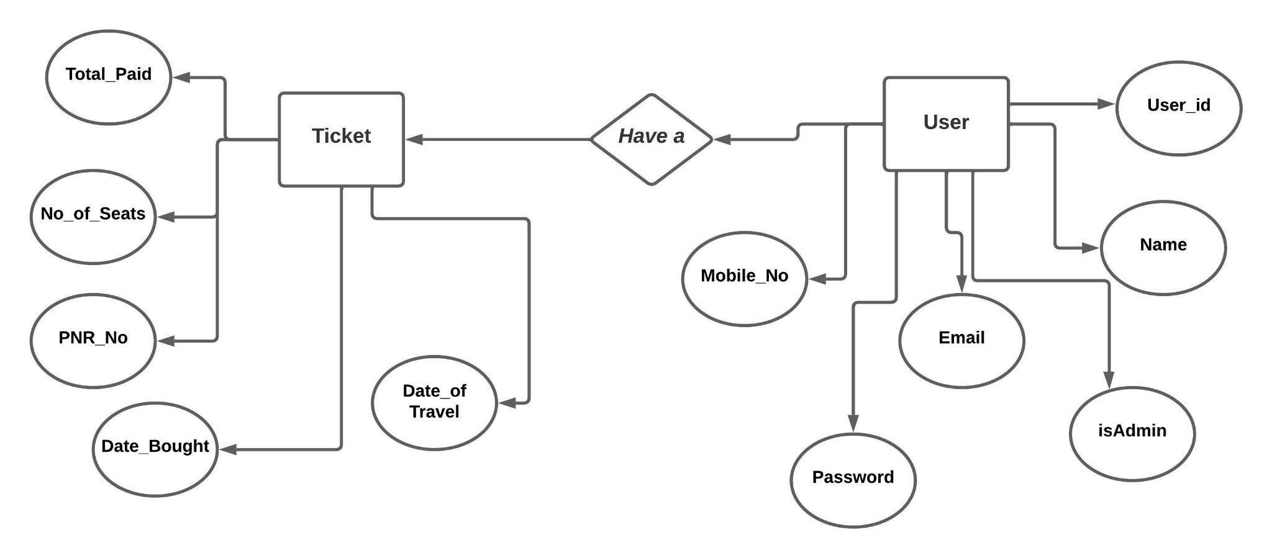

d) Class Diagram

6.5 Confirmation of Bus Ticket

1. Description

When the user selects the boarding station and destination station and books the ticket for the particular bus then the user will receive a 10 digit PNR number which will be unique for every ticket which will be used for the validation of tickets.

1. Process Flow Diagram

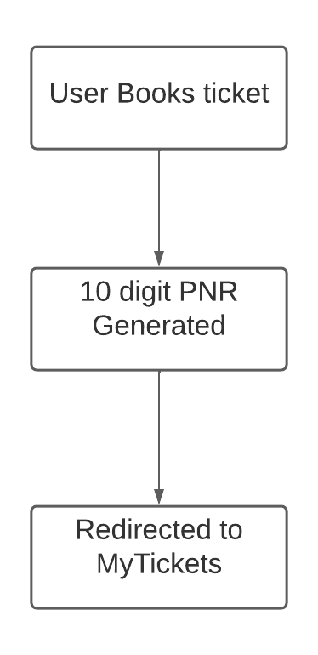

c) ER Mapping



6.6 Admin can add a new bus

a)Description

Authenticated admin can access the admin dashboard where a button to add new buses can be found. On clicking the button the admin will be taken to add new bus form. On filling up the bus data and upon successful data validation a new bus will be added to the database and the admin will be redirected to the bus list page.

b) Process Flow Diagram

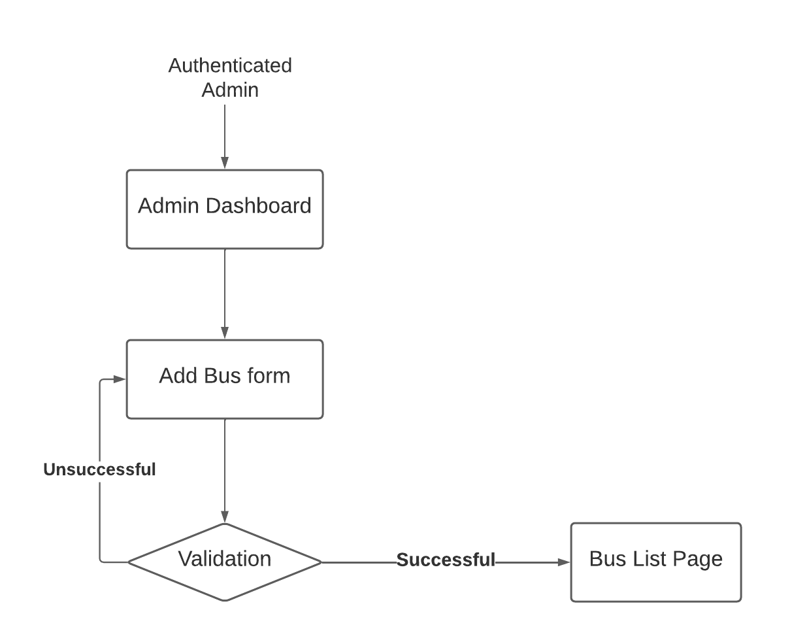

c)ER Diagram

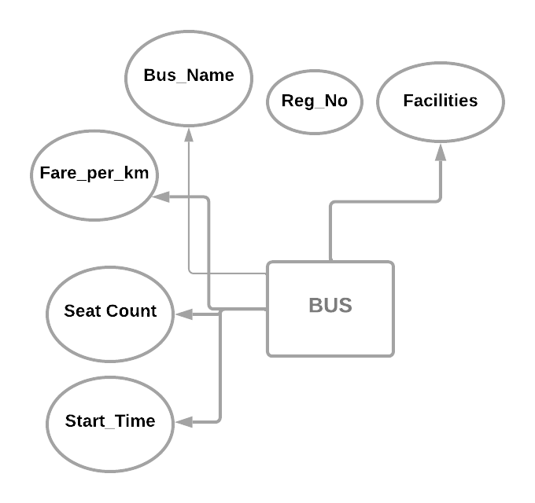

d)Class Diagram

6.7 Admin can disable a bus

## Description

The list of buses provides a disable button for each bus. Upon clicking the disable button, the particular bus will be identified in the database by its registration no and its isActive attribute will be set to false.

b) Process Flow Diagram

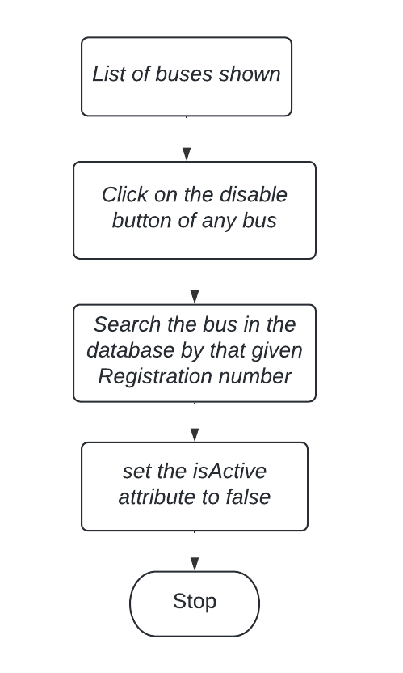

c)ER Diagram

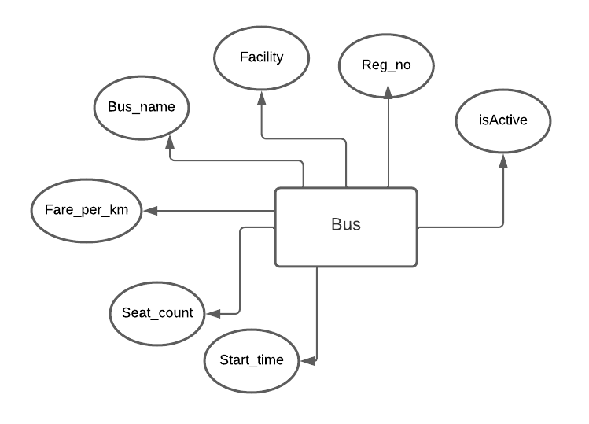

d)Class Diagram

6.8 Generate Revenue Report

a)Description

Admin can generate a revenue report for all routes for a 1 month time period and based on the report various managerial decisions can be taken like adding more buses to the route or disabling some bus on that route.

b) Process Flow Diagram

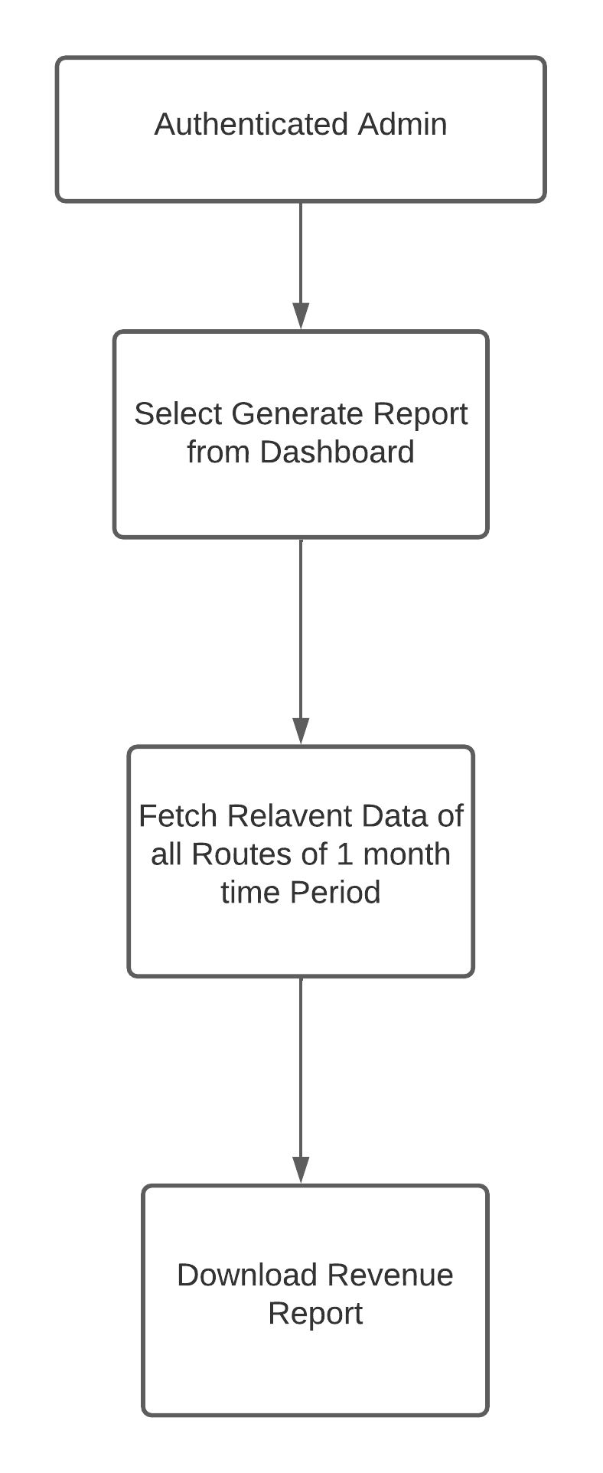

c)ER Diagram



d)Class Diagram

6.9 Admin can generate a list of tickets booked for a bus on a particular day.

1. Description

Admin will get the facility to generate the list of tickets booked for a bus on a particular date.

1. Process Flow Diagram

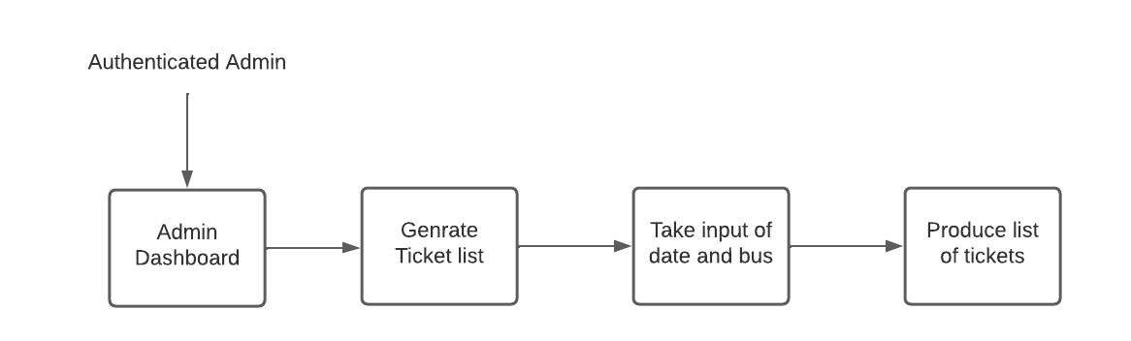

1. ER Diagram

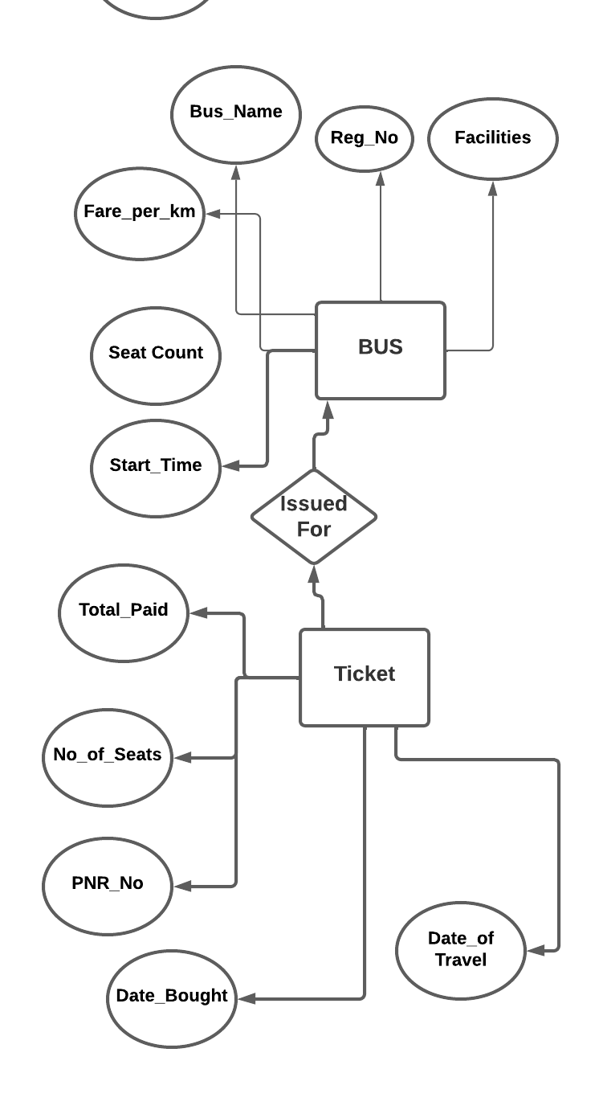

1. Class Diagram

# Design

## Forms

This section contains the information on every form (web) elements along with the constraints and format.

**Search bus form**

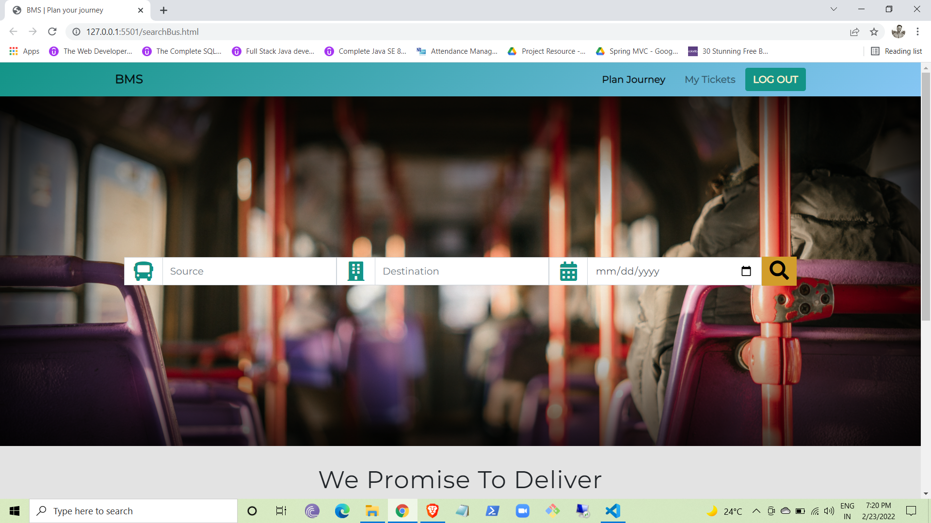

**User Login form**

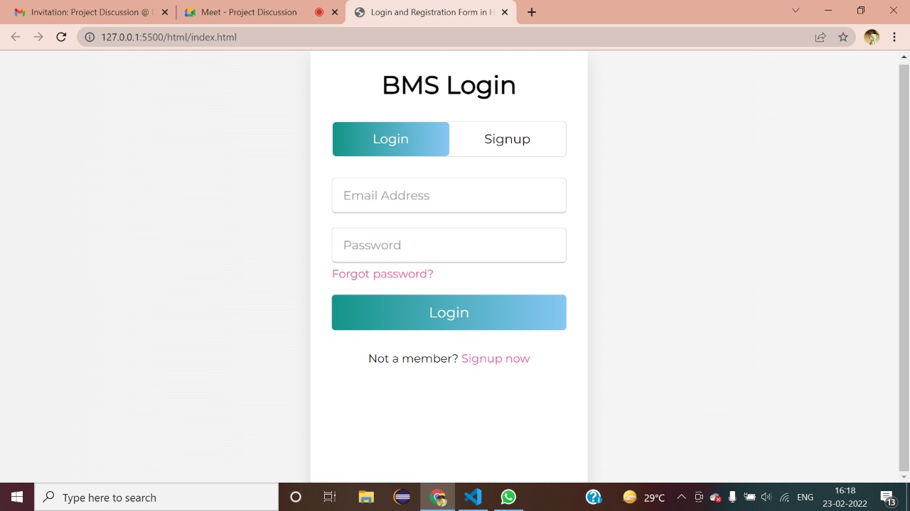

**User registration form**

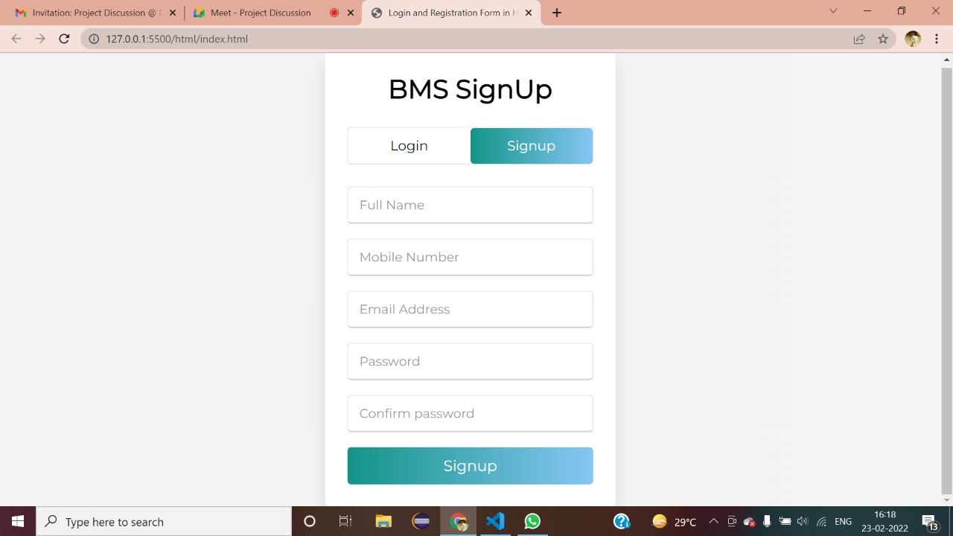

**Booking ticket form**

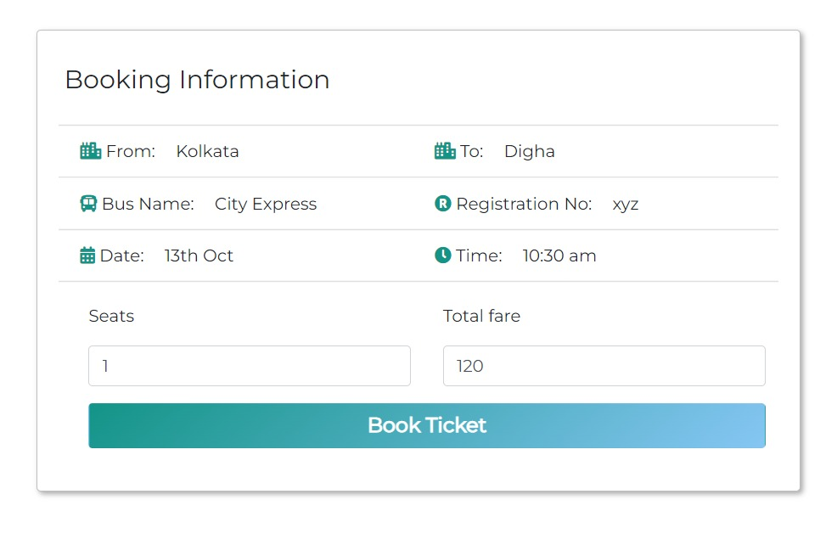

**Add Bus**

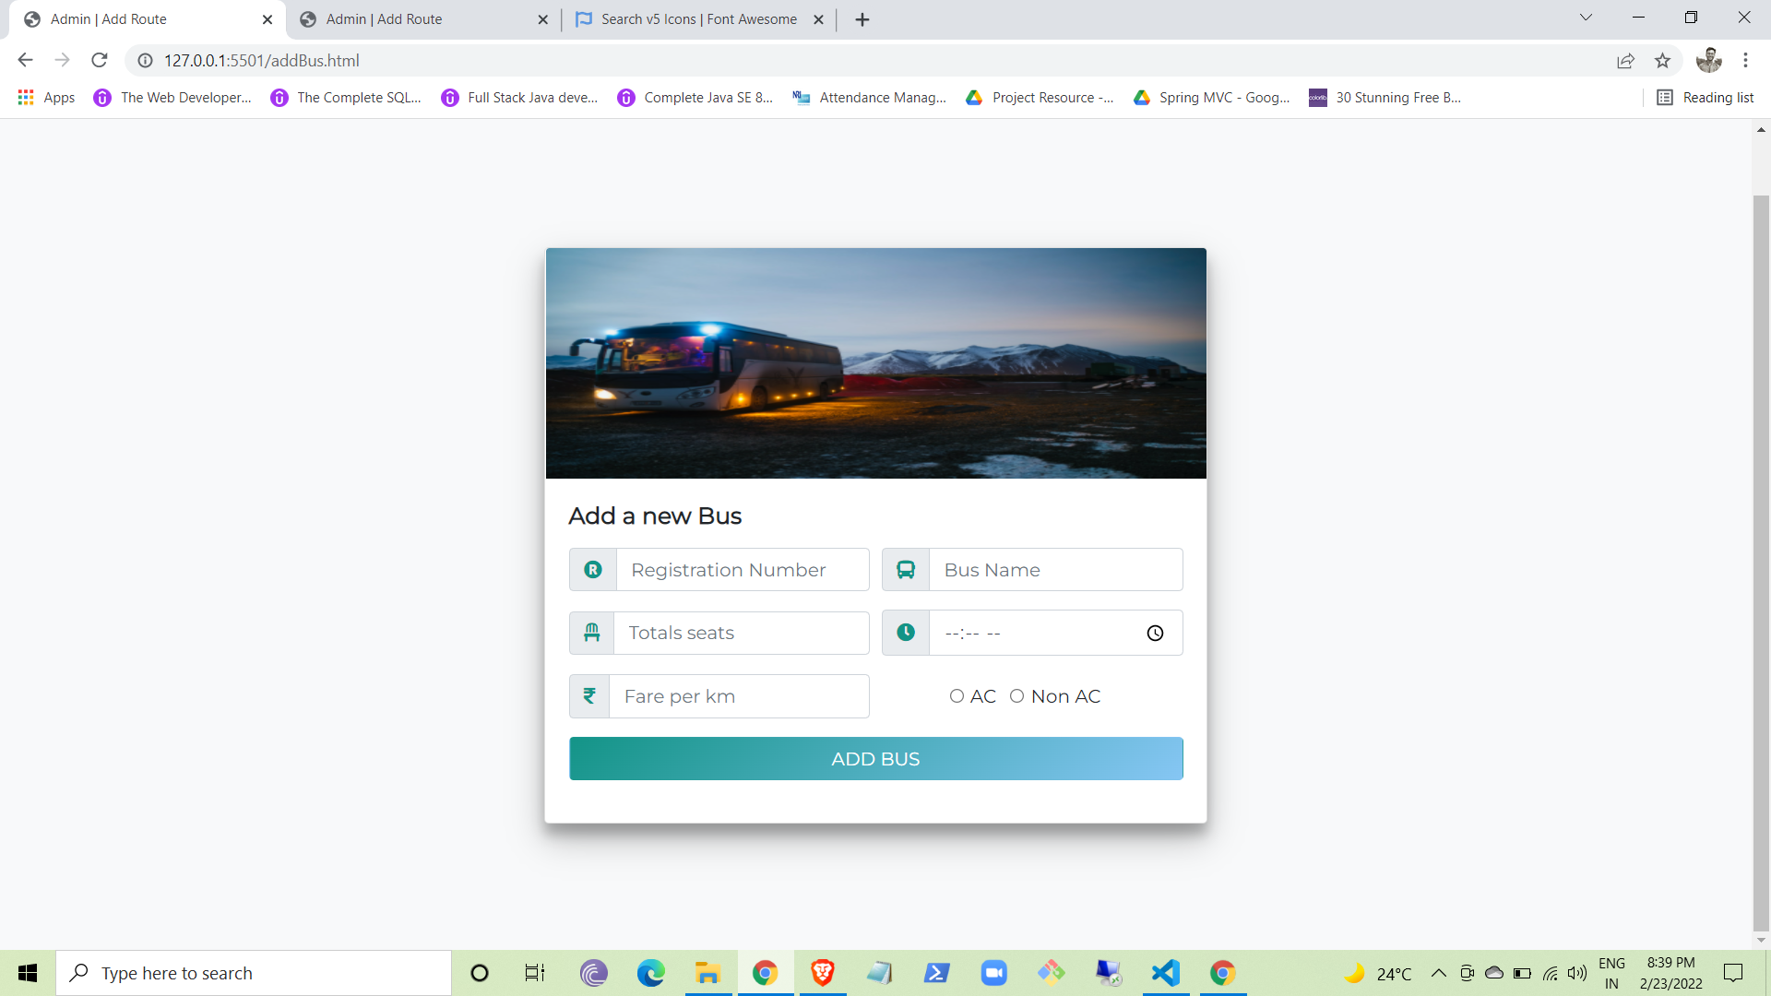

## Database

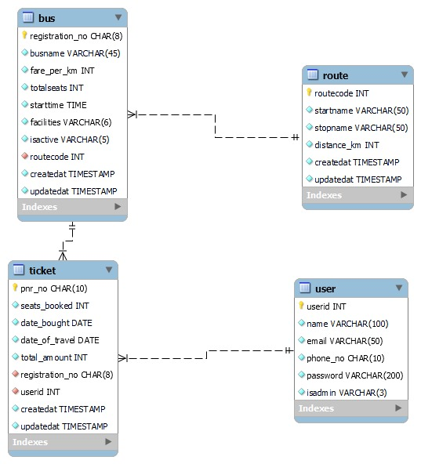

## Middle Tier

This section contains the Java class and Java package information in detail.

# Data Unit Mapping

This section contains the relation between every forms elements with every database table-column and rules, if any, exists.

| Form | HTML Form Name | Form Tag | Tables | Column Names | Column Types |
| --- | --- | --- | --- | --- | --- |
| Search Bus | From  To | Select  Select | route | startname  stopname | Varchar(50)  varchar(50) |
| Login form | Email  Password | email  password | user | email  password | varchar(50)  varchar(200) |
| Signup form | Full Name  Email  Mobile Number  Password | text  email  tel  password | user | name  email phone_no  password | varchar(100)  varchar(50) unique  char(10) unique  varchar(200) |
| Booking ticket form | Seats | number | ticket | seats_booked | int check(>0) |
| Add Bus | Registration no  Bus Name  Fare  Seat Count  Facilities  Route Code | text  text  number  number  select  select | bus | registration_no  busname  fare_per_km  totalseats  facilities  routecode | char(8)  varchar(45)  int check(>1)  int check(>20)  Varchar(6)  int |

# Acronyms and Abbreviations